
Yeovil Without Parish council
Small grant assistance to local organisations application form

Please refer to the councils policy, procedure and guidelines before the completing this form.

DETAILS OF ORGANISATION
Name |  |  |  | Registered Charity? Yes/No  (If yes, please give registration number)
Address

Aims and objectives of the Organisation

When was the organisation established. |  | What are your membership fees/annual subscription fees |  |  |  | Current number of members
Do you have a constitution or a set of governing rules? Yes/No  If yes, please provide copy with this application.  If No, please explain management structure below |  |  | Membership eligibility
Management Structure (if applicable)

Benefit to Yeovil Without Parish Council Please describe how your Organisation helps to benefit the people of Yeovil Without Parish - include supporting information as necessary

Finance - Year | Income |  | Expenditure |  | Reserves

For office use
Application checked
Application acknowledged
Date of Committee Meeting
Application decision (Y/N)
Applicant notified of decision

GRANT REQUSET
Purpose of grant sought - Please note that retrospective applications will not be considered.
The purpose should not be for a regular item of maintenance or such other revenue item, e.g. ongoing expenses and staffing costs.

Amount of grant sought - You must indicate the sum of money you are seeking from the YWPC. Applications not specifying an amount will not be considered.
If there is a shortfall how will the rest be funded
Outstanding grant applications - Please give details, including amount(s), of outstanding applications for financial assistance from other sources
Details of any grant received from Yeovil Without Parish Council in the past five years. Please include amount(s)

Details of any other grants received from other sources in the past five years
Please include amount(s)

 | YWPC Application for Small Grant Assistance to Local Organisations
Details of Organisation
Name

Address
Details of person applying on behalf of the Organisation
Name |  | Correspondence Address (if different to details of organisation) |  | Tel No
Position in Organisation |  |  |  | E-mail address
Bank Details
Account Name |  | Sort Code |  | Account No
Declaration
The declaration must be signed by an authorised person within the organisation, e.g., Committee Member, Office Holder, Trustee etc.
- I am authorised to make the application on behalf to the above organisation.
- I have read and noted the Council’s criteria relating to this application and agree to abide by the conditions listed if a grant is awarded by the Council.
- I certify that the information I have provided in this application is, to the best of my knowledge, accurate and true.
- I give permission for the Council to record the details of my organisation and my contact details and to retain the information for as long as it is required.
- If the application is successful, I give permission for the Council to publicise the project/activity in the local media, social media and on its website.
- I agree to recognise Yeovil Without Council’s grant award in any publicity relating to this project/activity.
- I agree to provide a report, including photographs, indicating how the grant awarded has been spent in accordance with the application.
- I submit the following (where appropriate): Safeguarding Policy
Public Liability Insurance
Signed:  Position: |  |  | Date:

This page will be kept separate from the application form in order to comply with General Data Protection Regulations (GDPR). All personal information provided will be processed in accordance with the requirements of the GDPR. Please see the Privacy Notice for details which can be found at Publications – Yeovil Without Parish Council A copy is available on request.

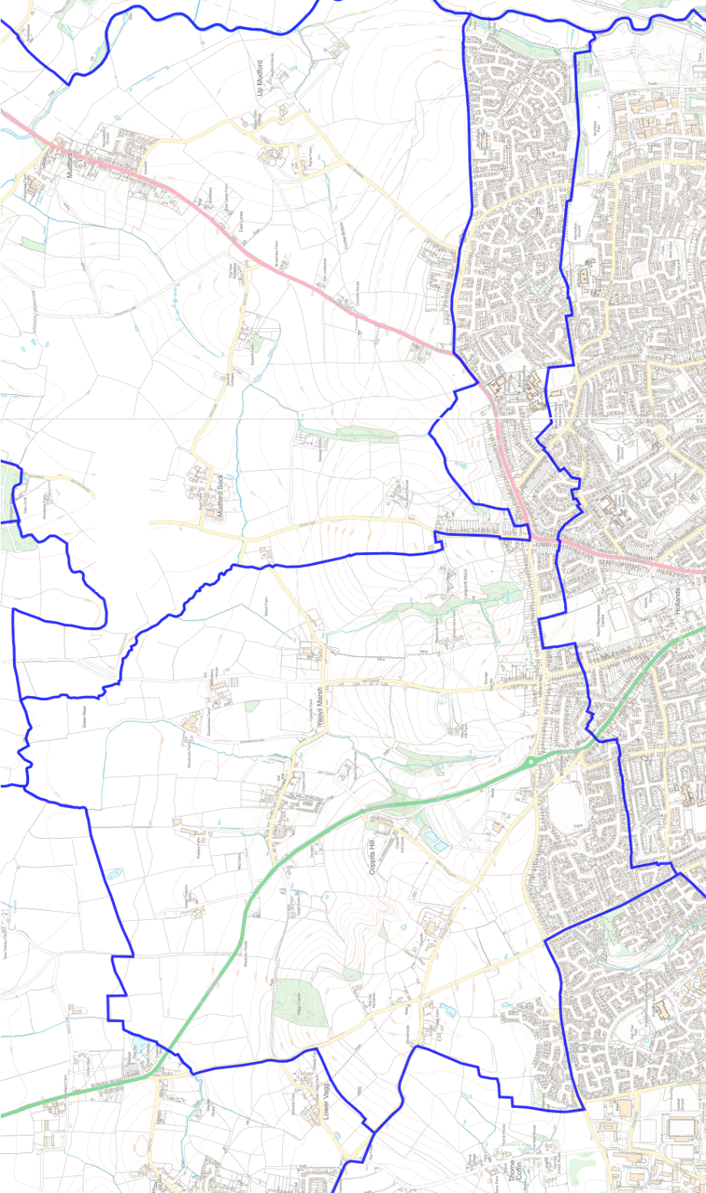
CHECKLIST
Please enclose the following with your application. We will only process your application when we have received them. Please Tick
Signed application form, with every question answered
Latest audited annual accounts
Constitution or set of rules (if not applicable please state N/A)
Bank statement no more than 3 months old
Copies of written estimates/quotations for equipment
If possible, please email a copy of the grant application (with all supporting documentation) to the Clerk (clerk@yeovilwithoutparishcouncil.gov.uk) or alternatively send your completed application and supporting documentation to: Yeovil Without Parish Council, 15 Heather Way, Yeovil, BA22 8DZ You are advised to keep a copy of this application for your own records.

Yeovil Without Parish boundary

I
I I
J
I

\

For office use
Application checked
Application acknowledged
Date of Committee Meeting
Application decision (Y/N)
Applicant notified of decision

For office use
Application checked
Application acknowledged
Date of Committee Meeting
Application decision (Y/N)
Applicant notified of decision

